Project Report

|  |  |
| --- | --- |
| **Course Name** | **Advanced Certificate in Data Science** |
| Product Name (Marketing & Sales) | ACDS |
| **Module Name** | **Data Science Essentials** |
| Product Name (Marketing & Sales) | Data Science Essentials |

|  |  |  |  |
| --- | --- | --- | --- |
| Student name | | Assessor name | |
| Toh Yi Ting | | Jeyashree Rajkumar | |
| Date issued | Completion date | | Submitted on |
| 4 April 2024 | 19 April 2024 | | 19 April 2024 |
|  | |  | |
| Project title | Gender Classification with Azure ML – Designer Pipeline, Command, and Auto ML Jobs | | |

|  |
| --- |
| Learner declaration |
| I certify that the work submitted for this assignment is my own and research sources are fully acknowledged.  Student signature: Date: 19 April 2024 |

Content

1. Project Overview 2
2. Project Technical Environment 3
3. Screen-shots of each task of Activity 1 4
4. Screen-shots of each task of Activity 2 7
5. Screen-shots of each task of Activity 3 11
6. Screen-shots of each task of Activity 4 14
7. Screen-shots of each task of Activity 5 18
8. Conclusions and Future Directions 21
9. Project Overview: I will be working on the development of a gender classification model as a modular project at ABC Tech Solutions. The main objective is to understand the given dataset and utilize it for gender classification to discern features predictive of gender. The dataset encompasses various attributes which will be used to build a predictive model. I will execute the necessary tasks using Azure Machine Learning and MLflow. I will implement custom tracking with MLflow to log parameters, metrics, and artifacts. I will also use Azure Machine Learning's AutoML to refine, evaluate and enhance my predictive model.
10. Project Technical Environment: I will use Python SDK, Python 3.8 and the DP-100 Lab environment with Azure Subscription.
11. **Screen-shots of each task of Activity 1 (Include the code and screenshots of activity 1)**

**Activity 1: Resource Creation**

* **Task1:** Set Up Azure Machine Learning Workspace: create a new workspace in DP-100 Lab environment.

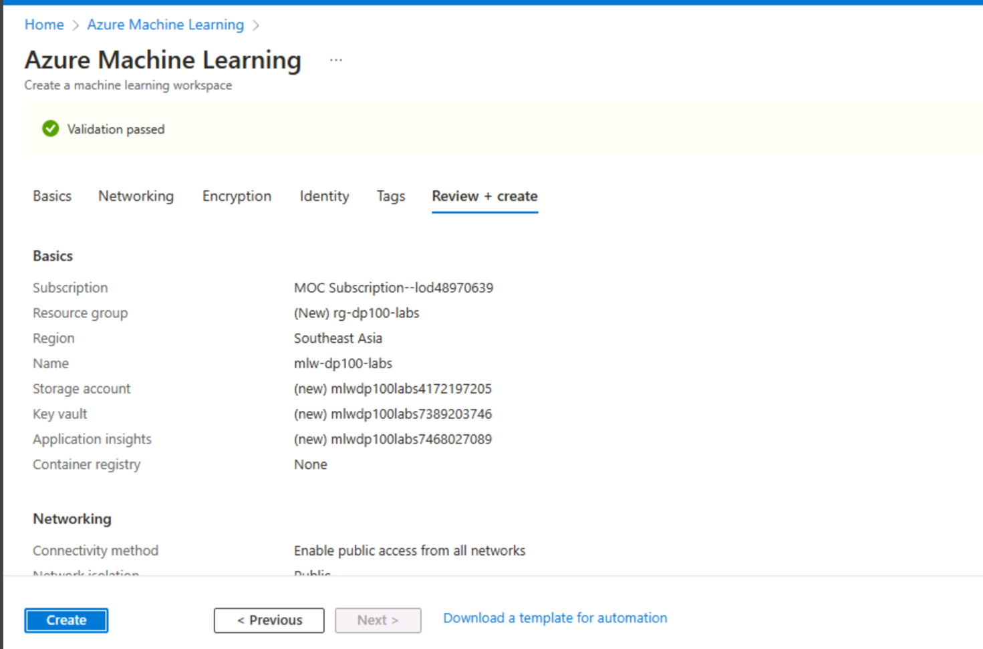

* **Task2:** Create Compute Instance: Establish a compute instance named **module-project-compute**. This instance will be used for running scripts, training models, and other development tasks.

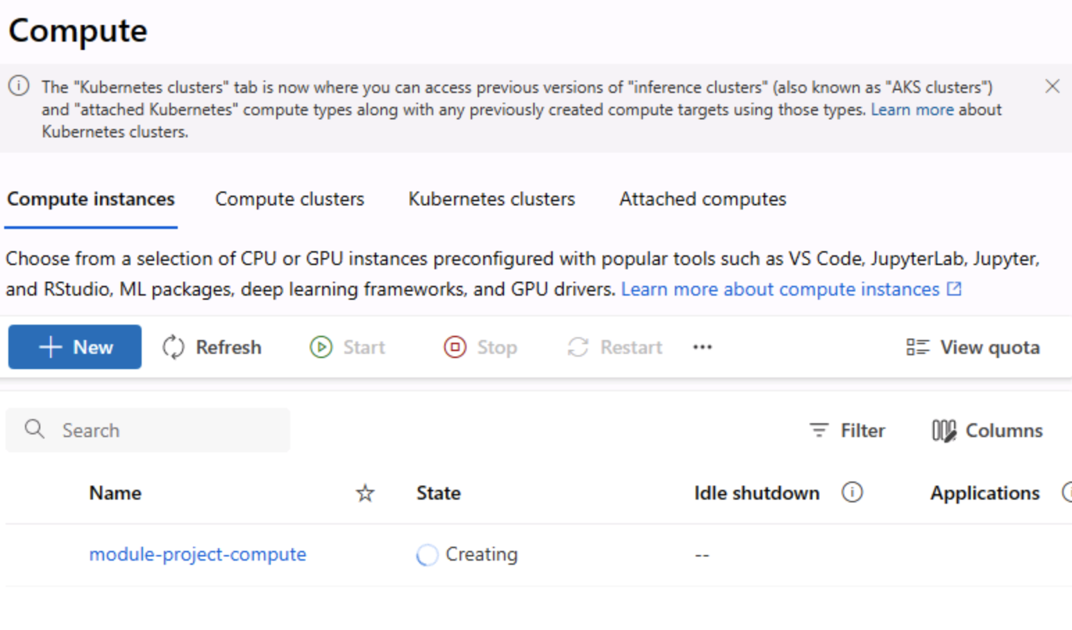

* **Task3:** Create Compute Cluster: Set up a compute cluster named **module-project-cluster**. This cluster will handle more demanding tasks such as large-scale model training and hyperparameter tuning.

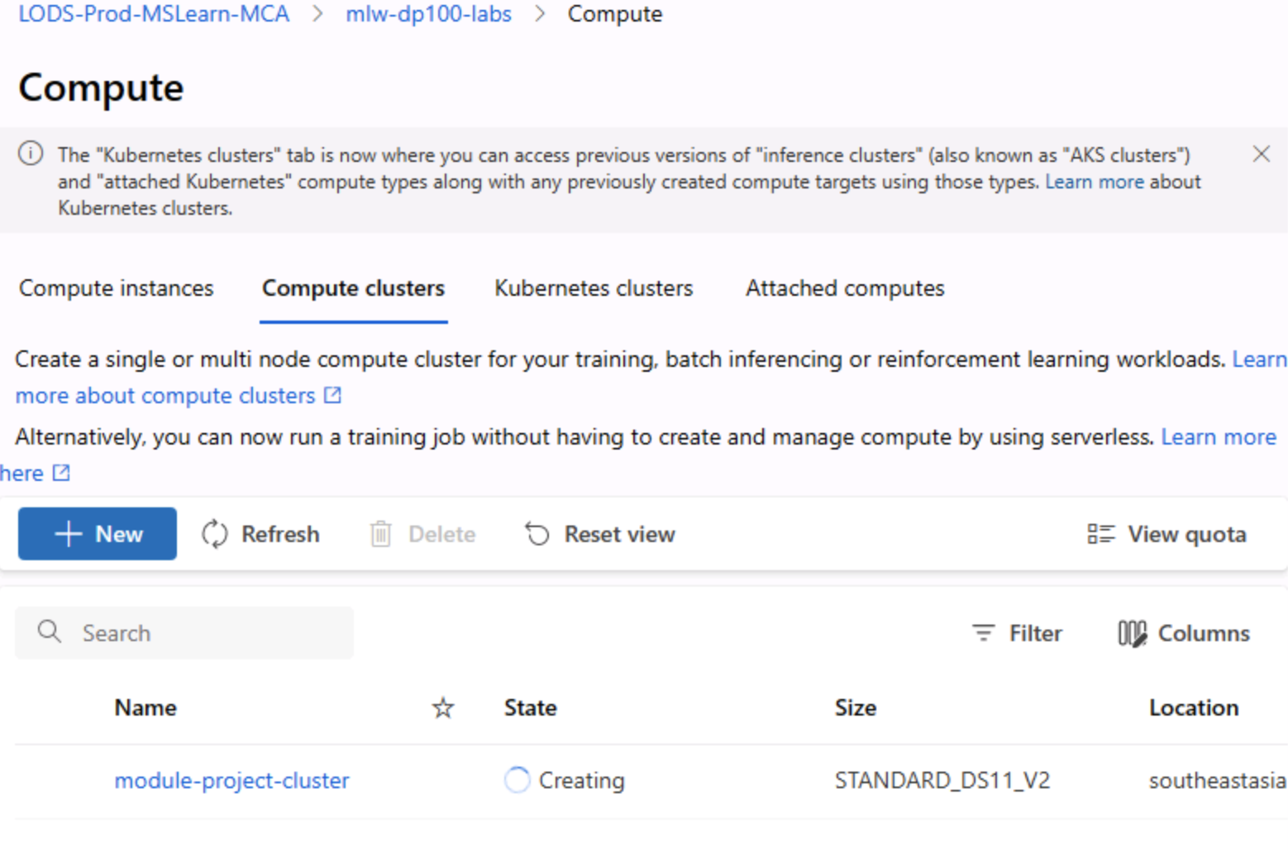

* **Task4:** URI File Data Asset: Register a URI file data asset under the name **genders-data**. This asset will contain the raw data necessary for training the gender classification model.

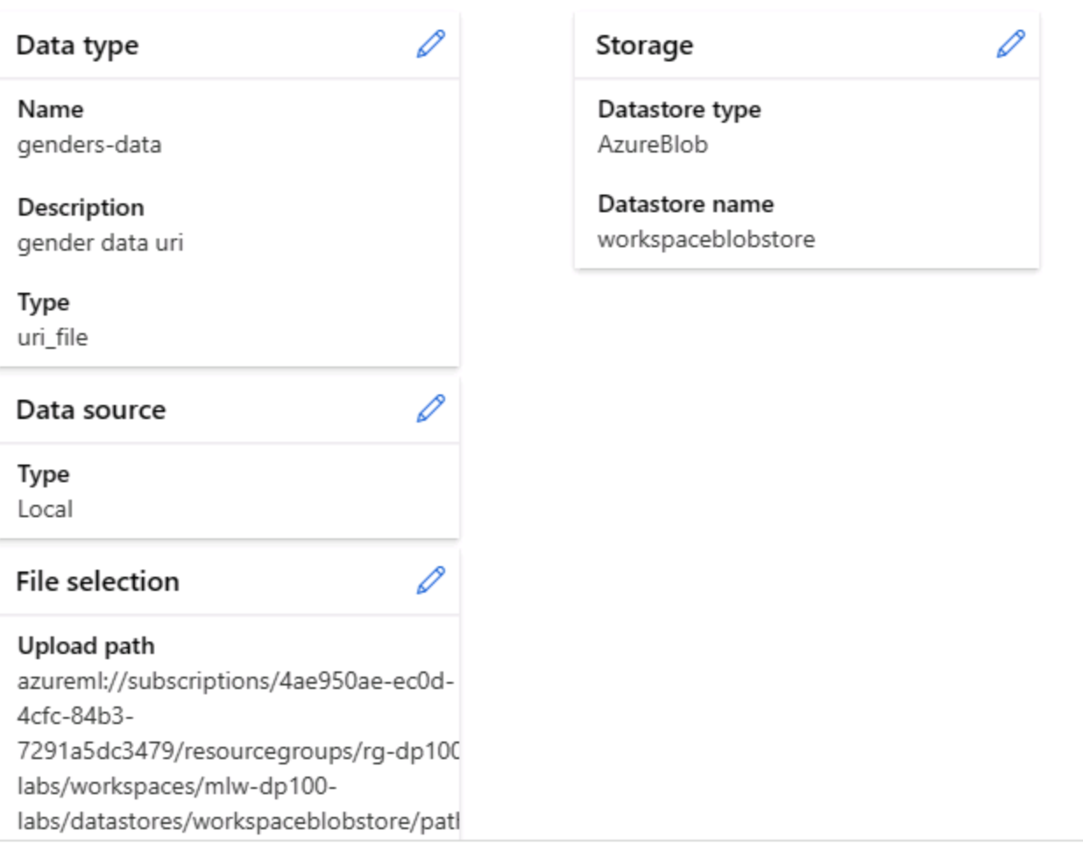

* **Task5:** MLTable Data Asset: Create an MLTable data asset named **gender_table**. This asset will be used to structure your data appropriately for the AutoML tasks.

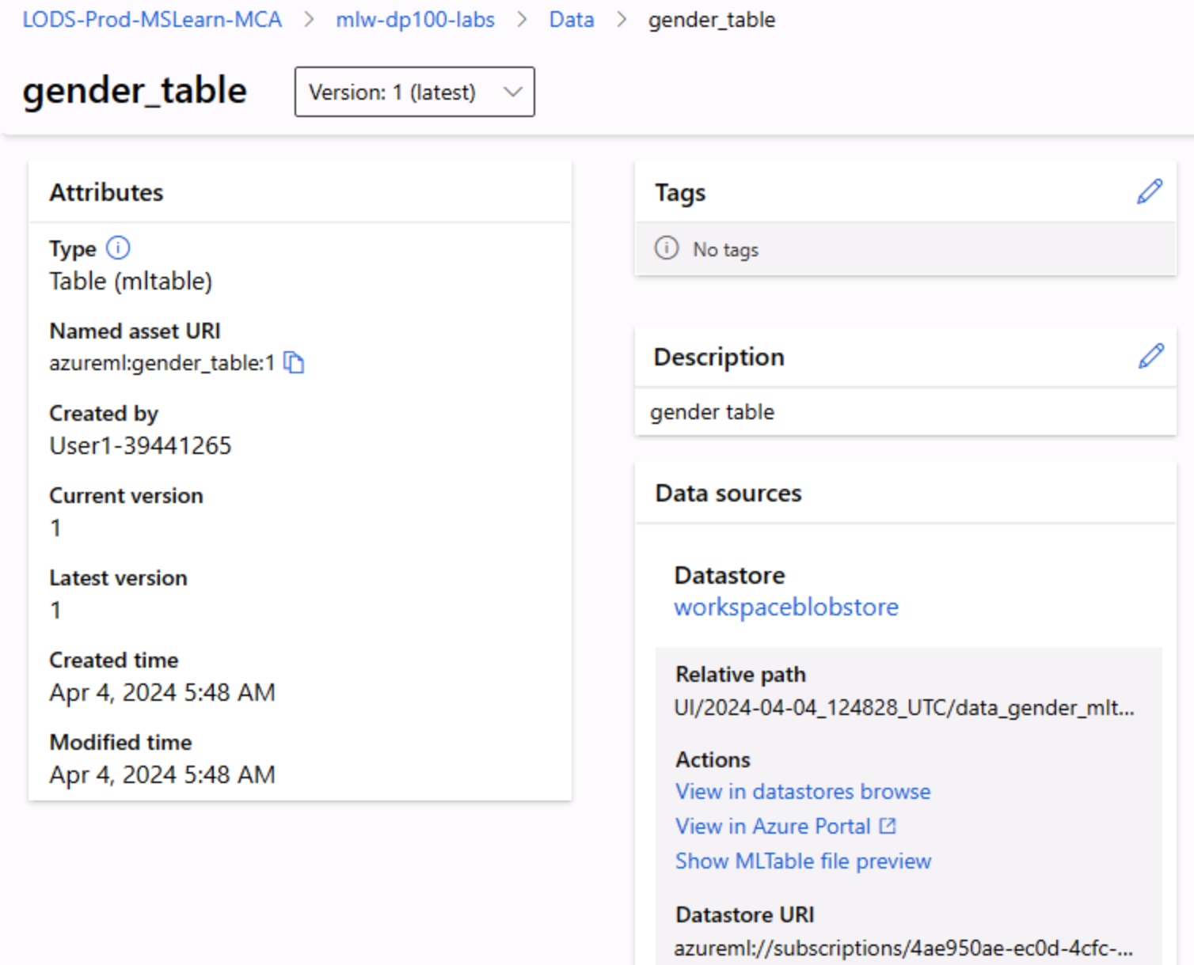

4. Screen-shots of each task of Activity 2 (Include the code and screenshots of activity 2)

Activity 2: Test with Azure ML Designer

* 1. **Task 1:** Create Tabular data asset namely “gender-tabular”
  2. **Task 2:** Choose the web source

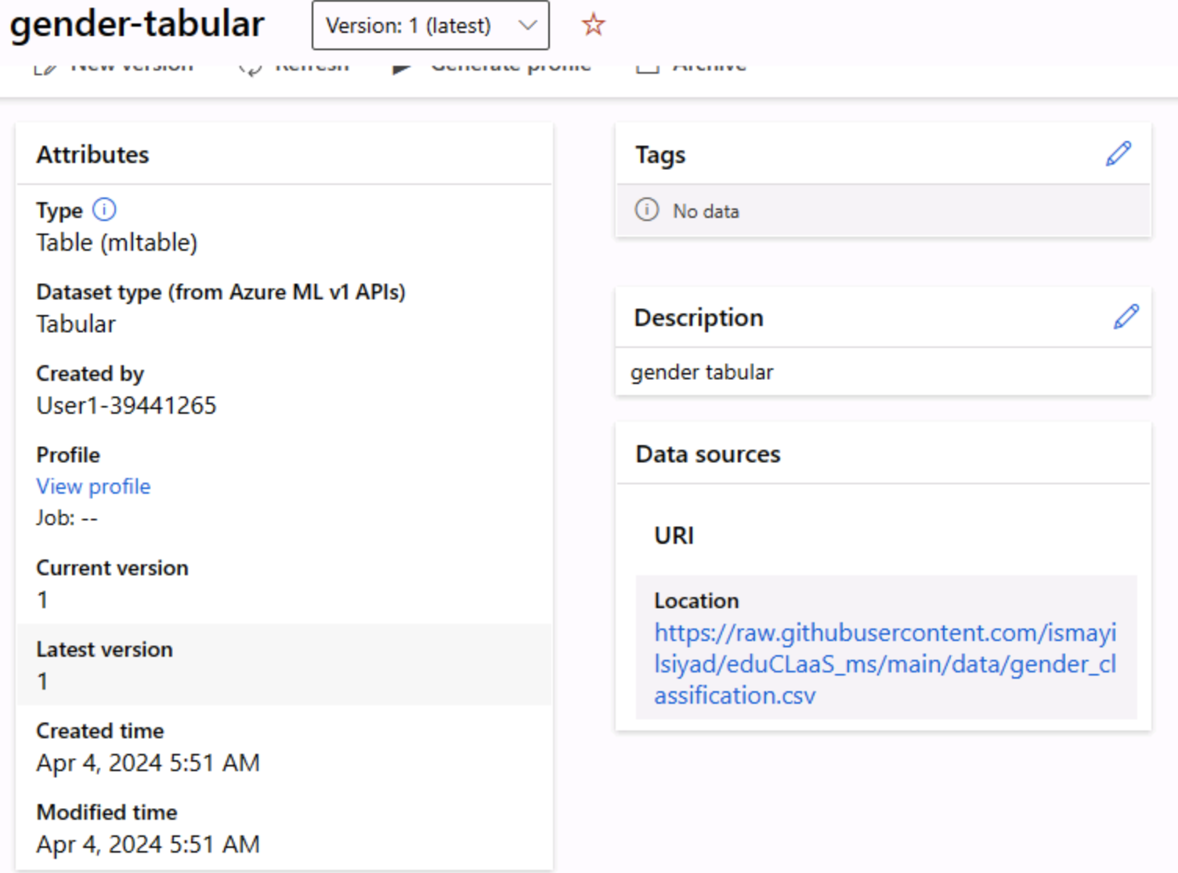

Task 3: Create a designer pipeline to train and evaluate the gender prediction model using Two- Class Logistic Regression.

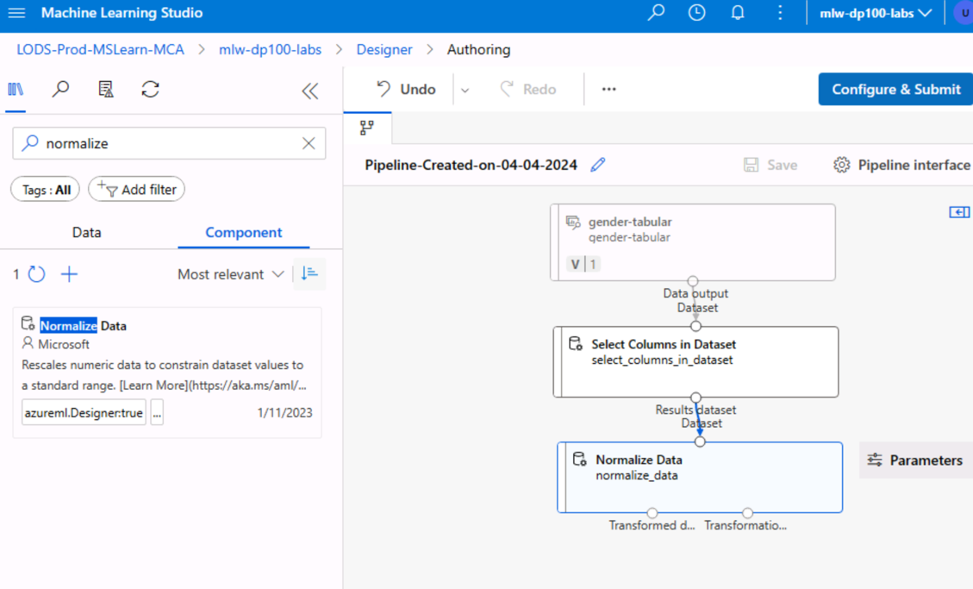

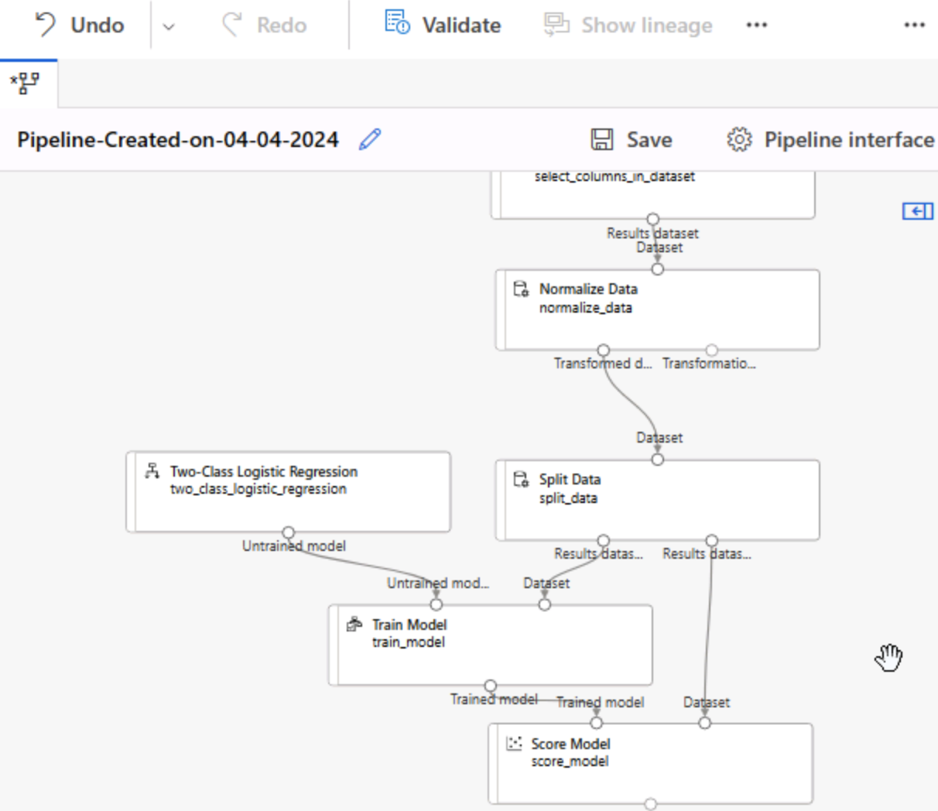

Task 4: Submit the training pipeline.

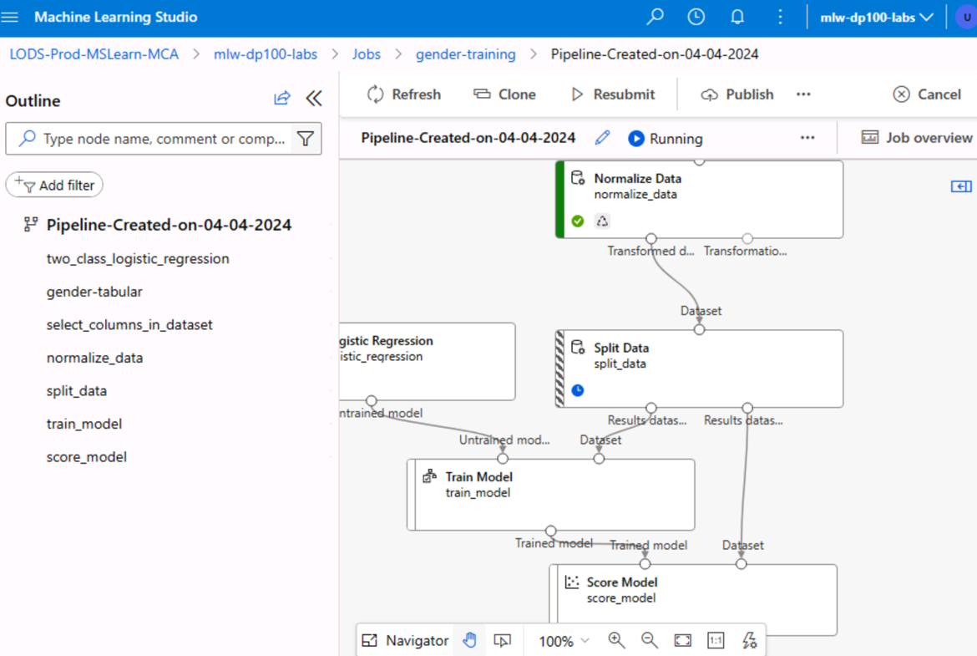

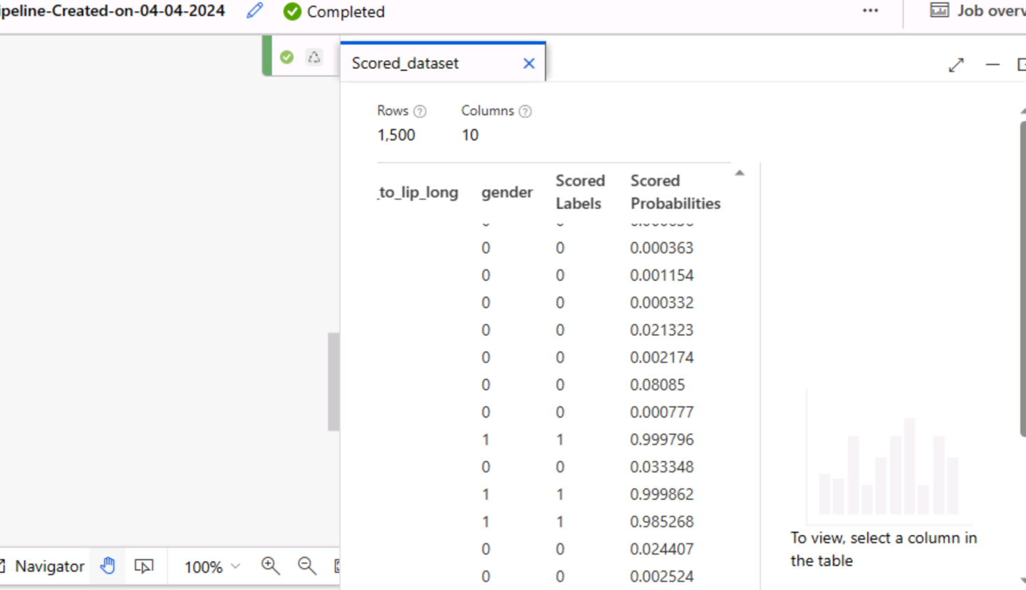

Task 5: Take the screenshots of executed pipeline job and evaluation metrics

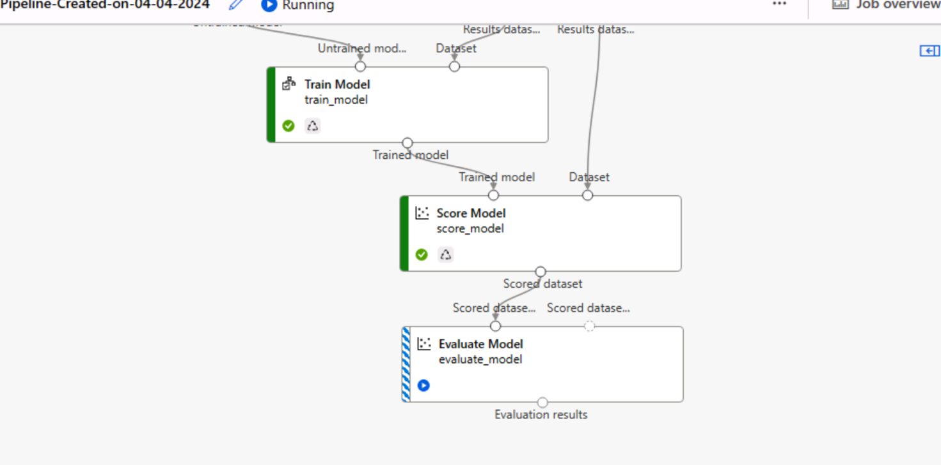

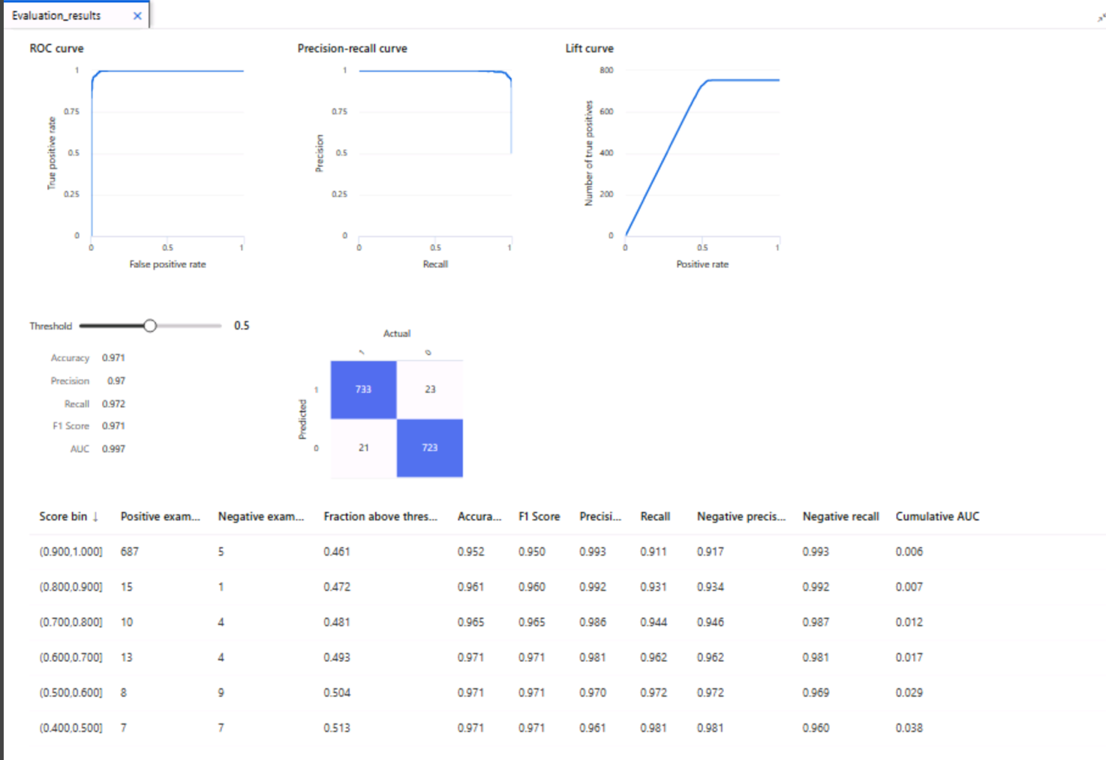

5. Screen-shots of each task of Activity 3 (Include the code and screenshots of activity 3)

Activity 3: Custom Tracking with MLflow

**Task 1:** Install the **azure-ai-ml** package on the compute instance using pip if not already installed.

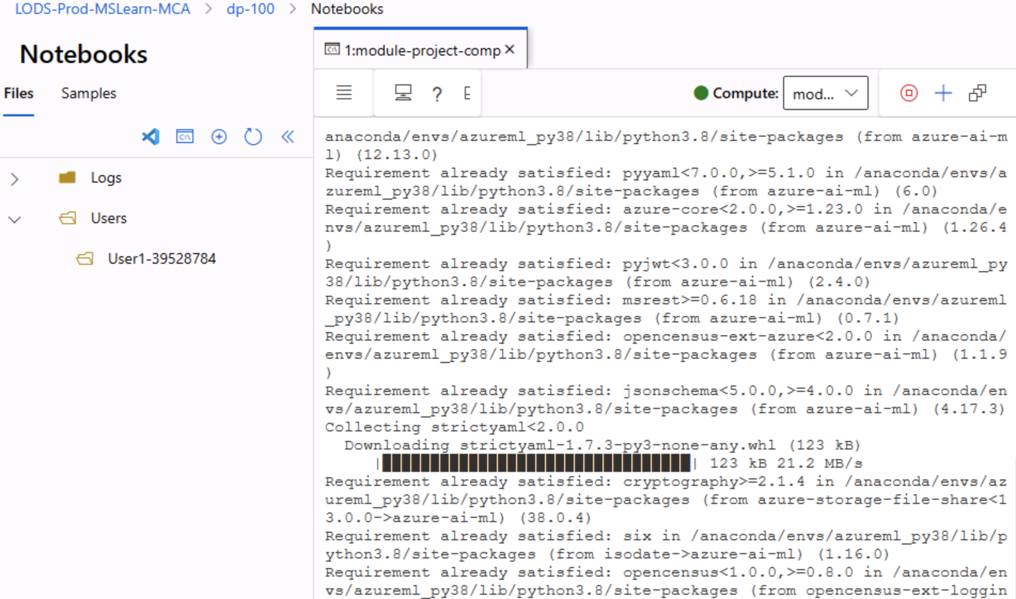

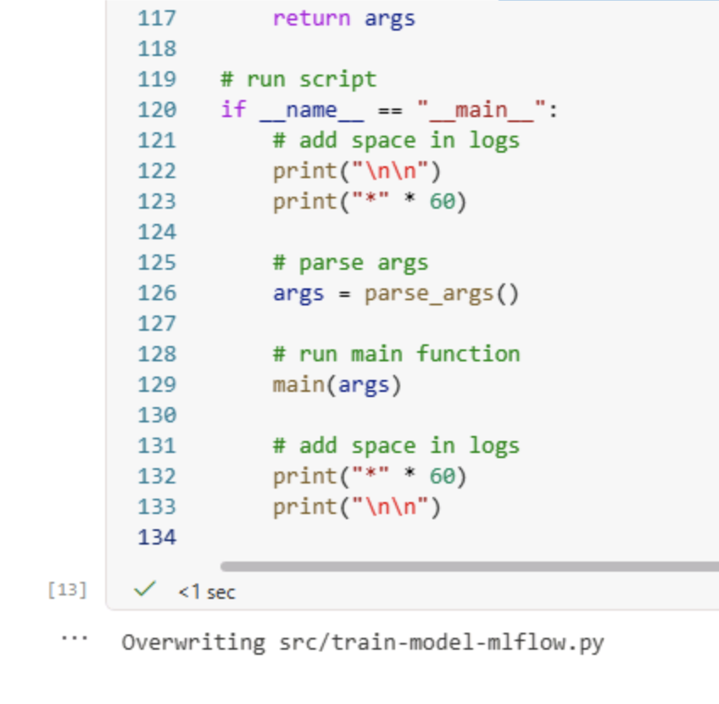**Task 2:** Write a Python script named **train-model-mlflow.py** in the **src** folder (You can download this script from the dataset section below the project brief) to train a gender classification model using the Logistic Regression algorithm. The script should log parameters, metrics, and artifacts (ROC Curve) with MLflow (You can refer the Lab notebook for custom tracking https://github.com/MicrosoftLearning/mslearn-azure- ml/blob/main/Labs/08/Use%20MLflow%20to%20track%20jobs.ipynb ).

**Task 3:** Submit the script as a command job in Azure ML, ensuring the environment and compute target are appropriately configured.

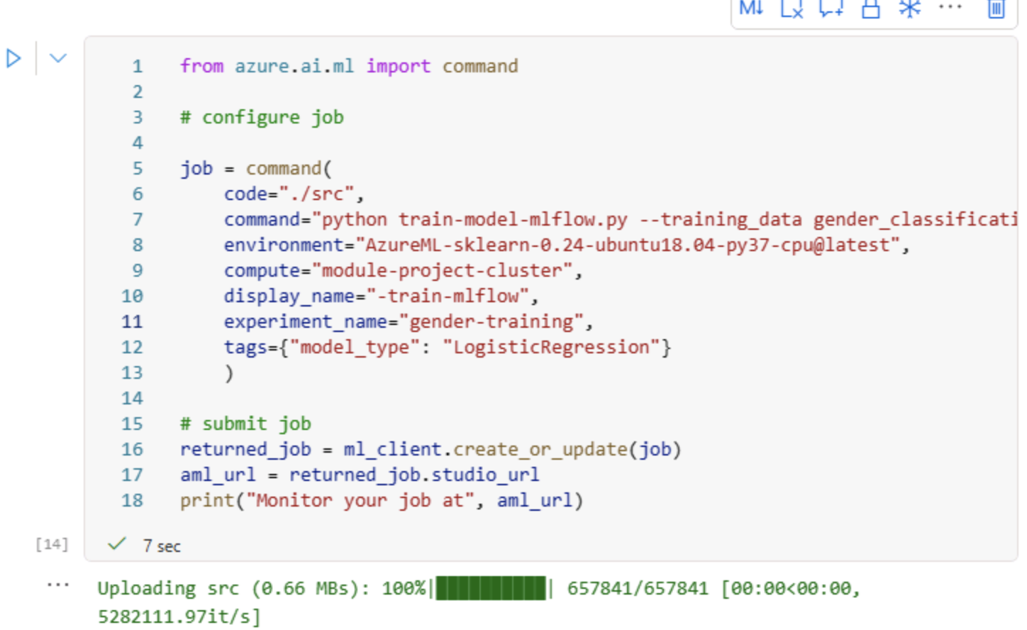

**Task 4:** Take the screenshots of command job’s status and the logged values.

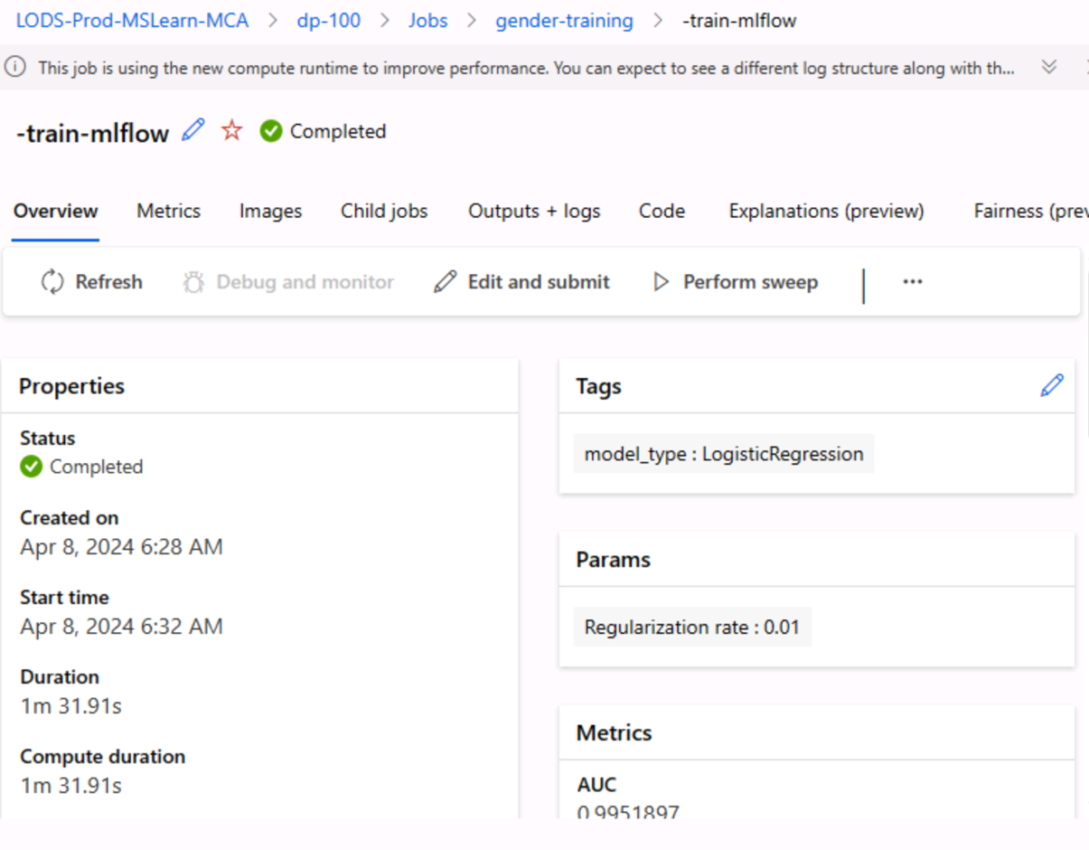

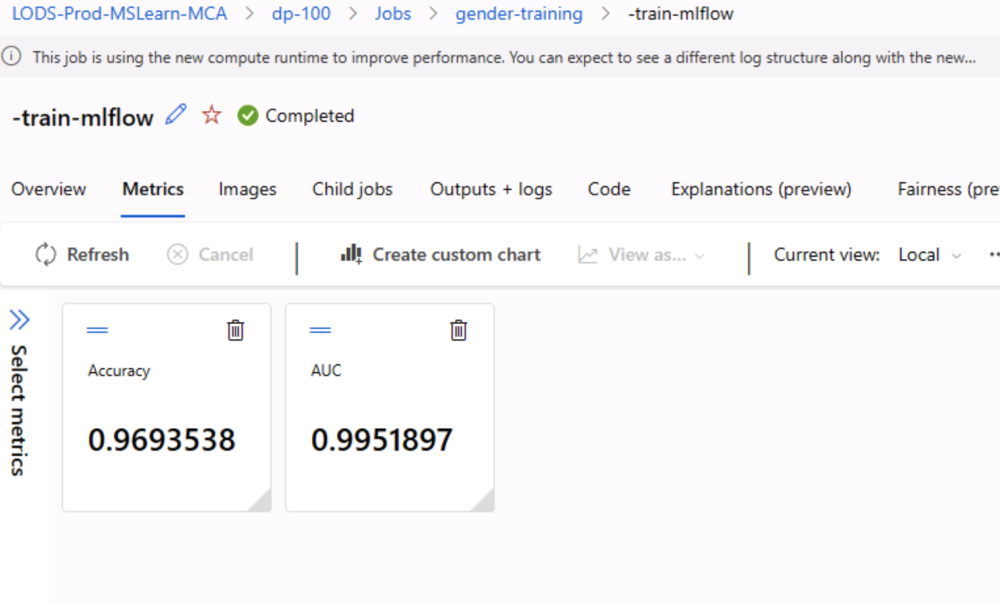

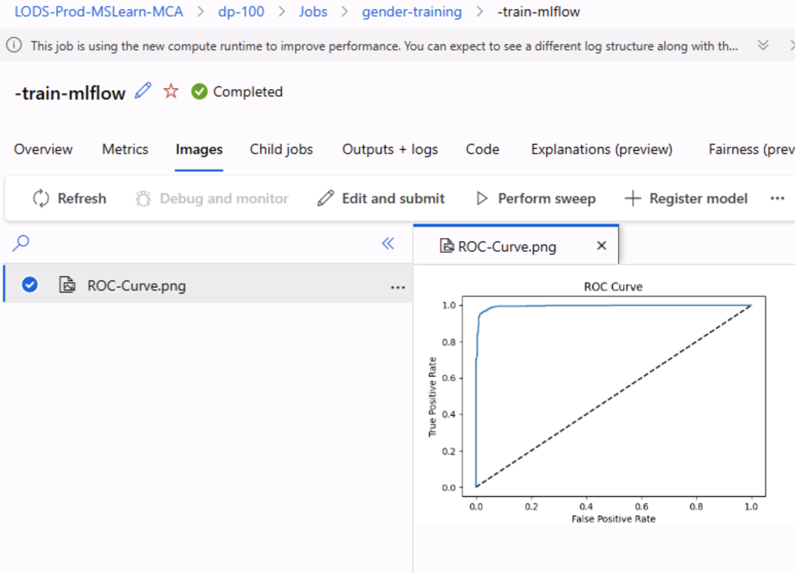

6. Screen-shots of each task of Activity 4 (Include the code and screenshots of activity 4)

Activity 4: Command Job with Auto Tracking

**Task 1:** Create a new Python script named **train-model-autolog.py** in the **src** folder by enabling MLflow's auto logging in the training script.

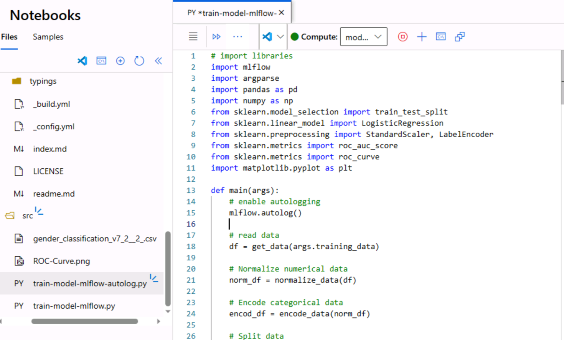

**Task 2:** Submit this script as a command job, similar to Activity 1 Task 3 (You can refer the Lab notebook for Auto tracking https://github.com/MicrosoftLearning/mslearn-azure- ml/blob/main/Labs/08/Use%20MLflow%20to%20track%20jobs.ipynb ). Monitor the job in Azure ML Studio and verify the autologging of parameters and metrics.

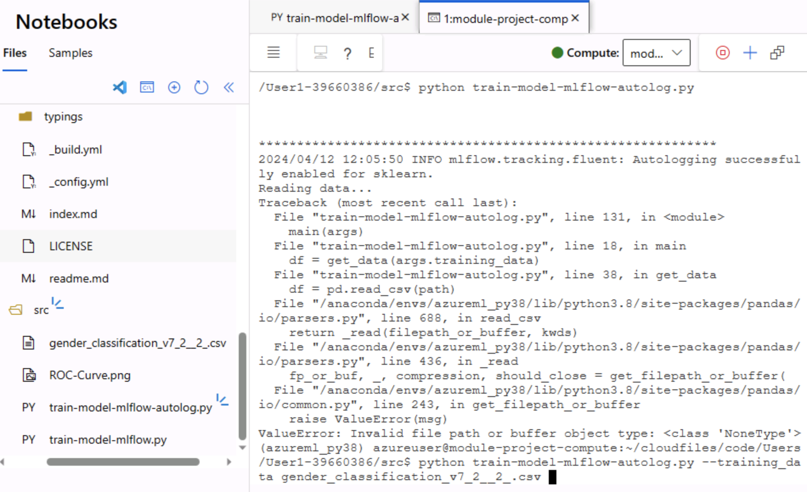

**Task 3:** Take the screenshots of command job’s status and the logged values.

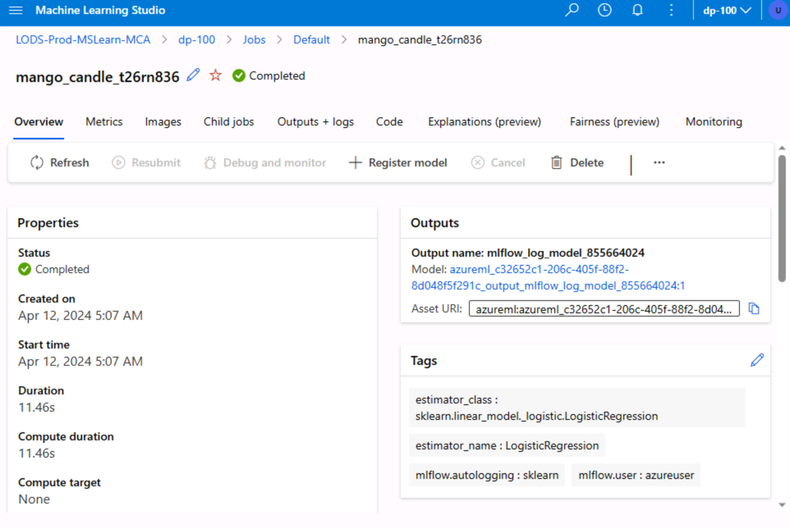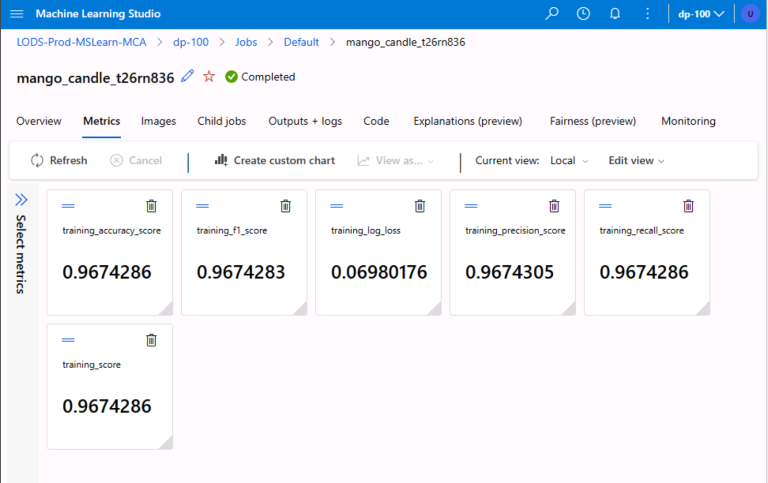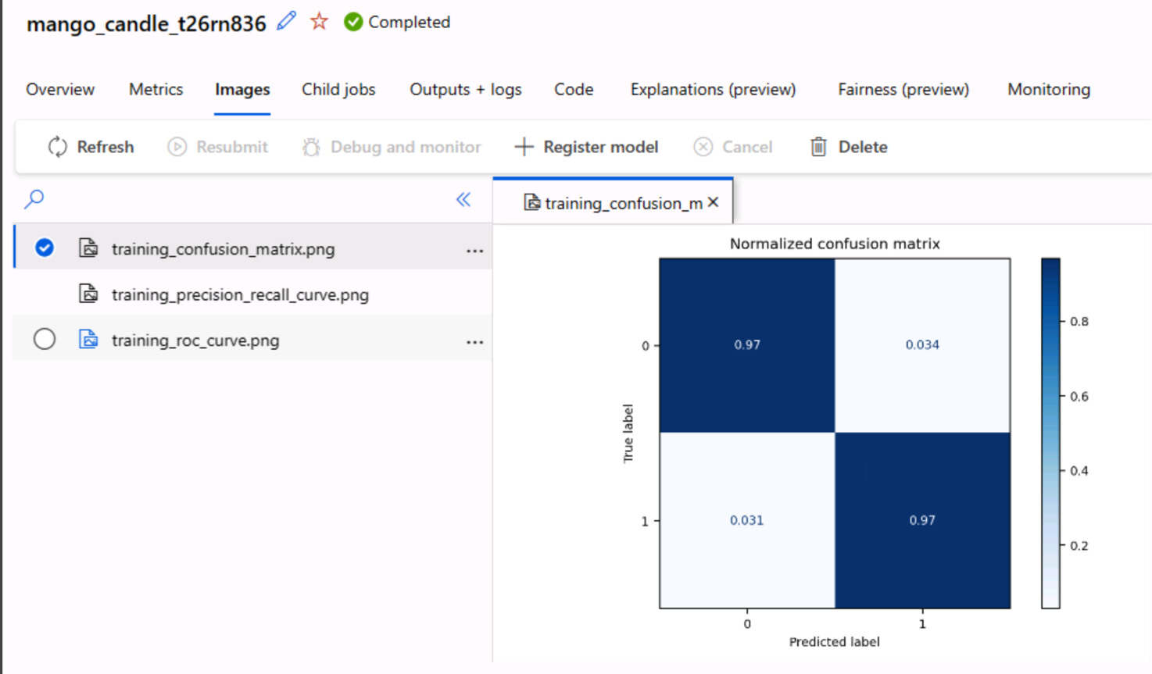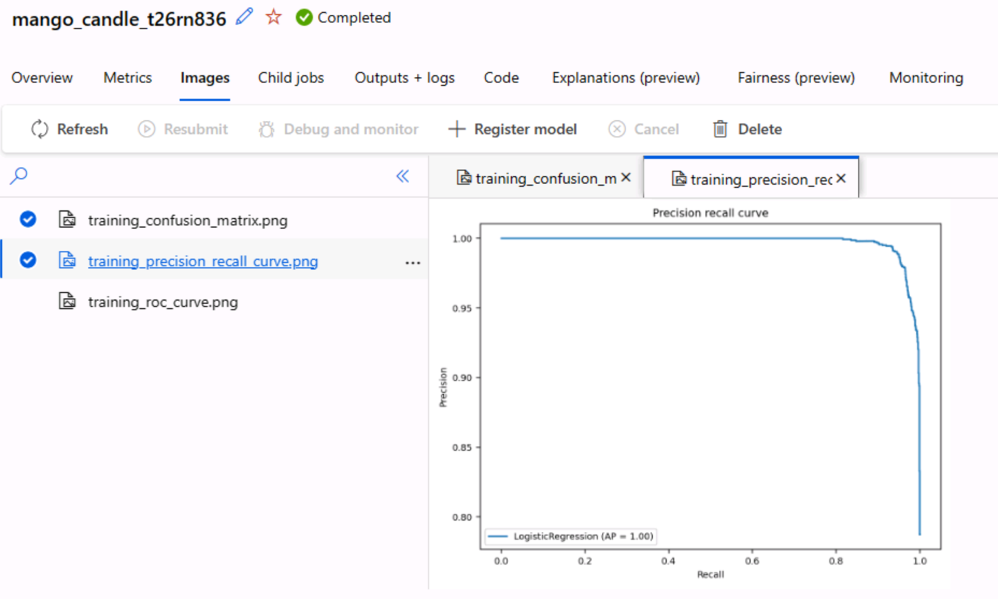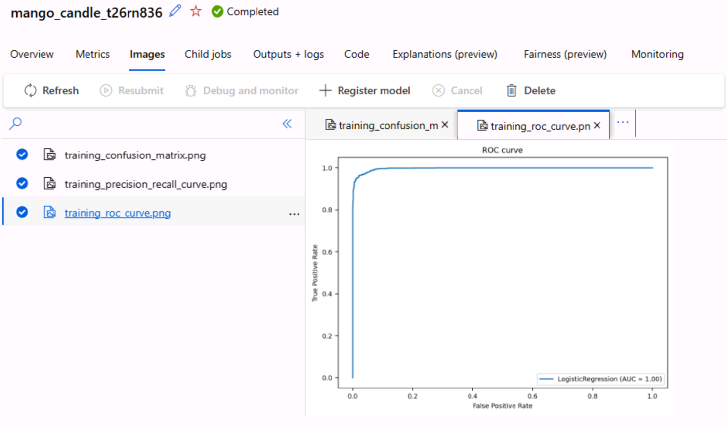

7. Screen-shots of each task of Activity 5 (Include the code and screenshots of activity 5)

**Activity 5: Automated Machine Learning (AutoML)**

**Task 1:** Prepare your training data to be compatible with AutoML, ensuring it's in MLTable format (We have already created MLTable data asset in Activity 1).

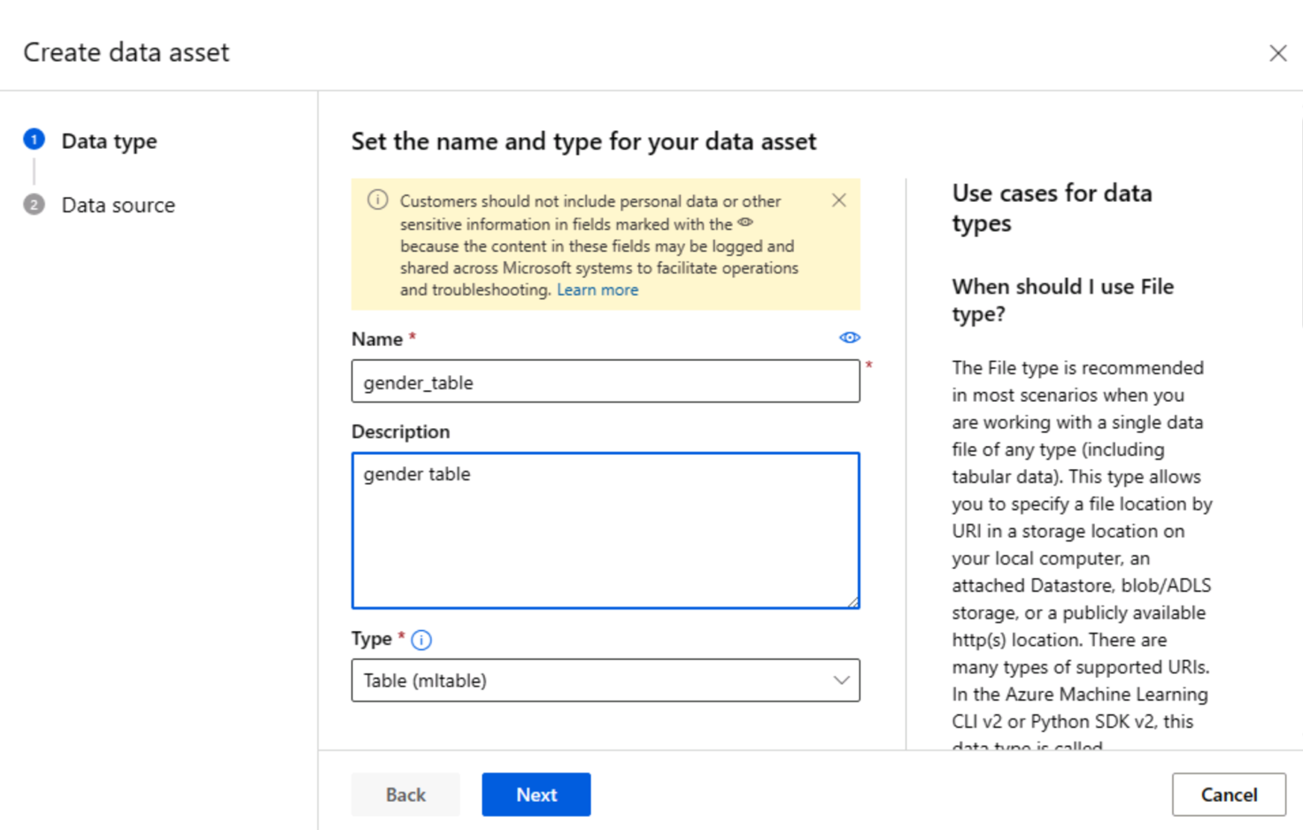

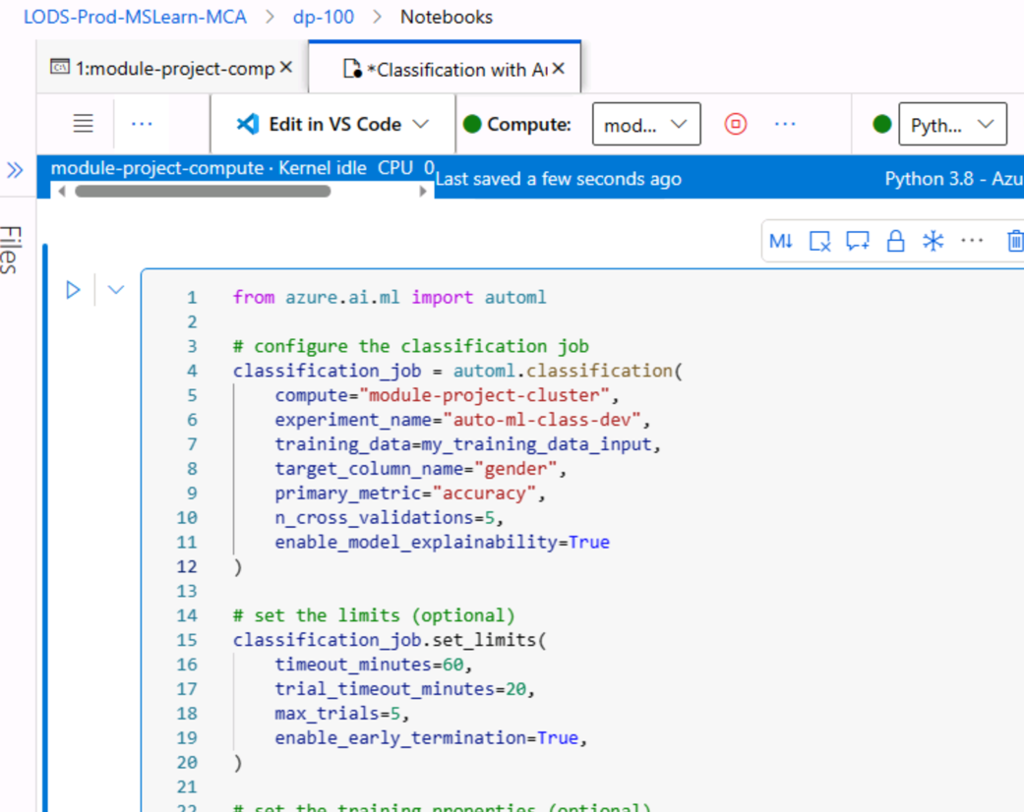**Task 2:** Configure an AutoML classification job in Azure ML (You can refer the Lab notebook for Auto ML https://github.com/MicrosoftLearning/mslearn-azure- ml/blob/main/Labs/06/Classification%20with%20Automated%20Machine%20Learning.ipynb ) , defining your compute target, primary metric, and other necessary settings.

**Task 3:** Submit the AutoML job and monitor its progress in Azure ML Studio.  
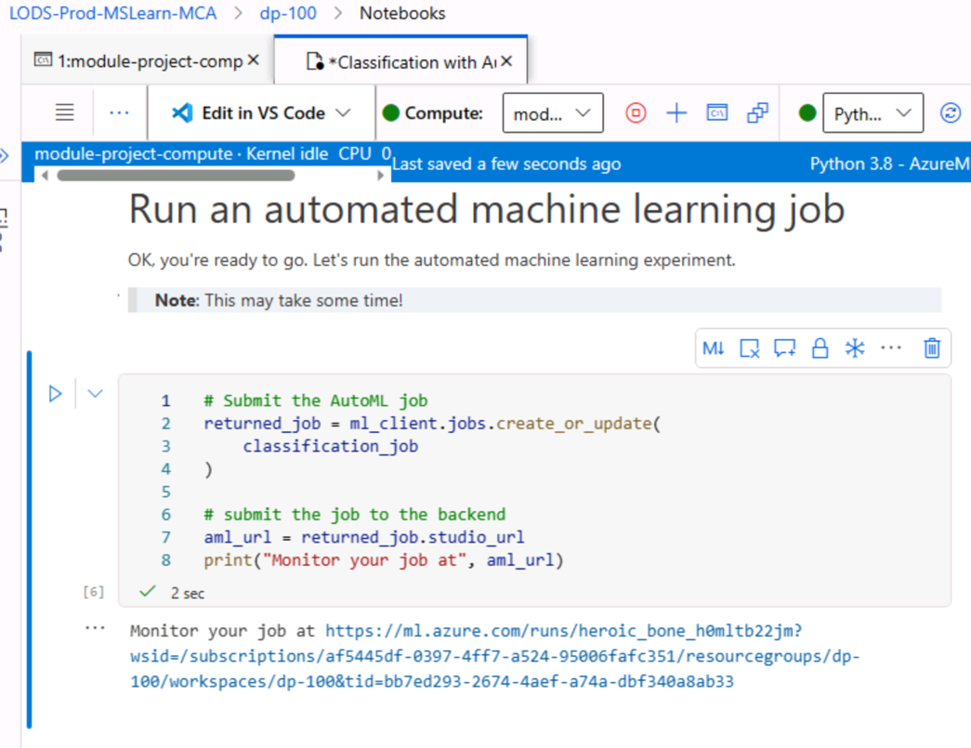

**Task 4:** Review the results and identify the best performing model based on accuracy.  
**Best performing model based on accuracy: VotingEnsemble (97% accuracy)**

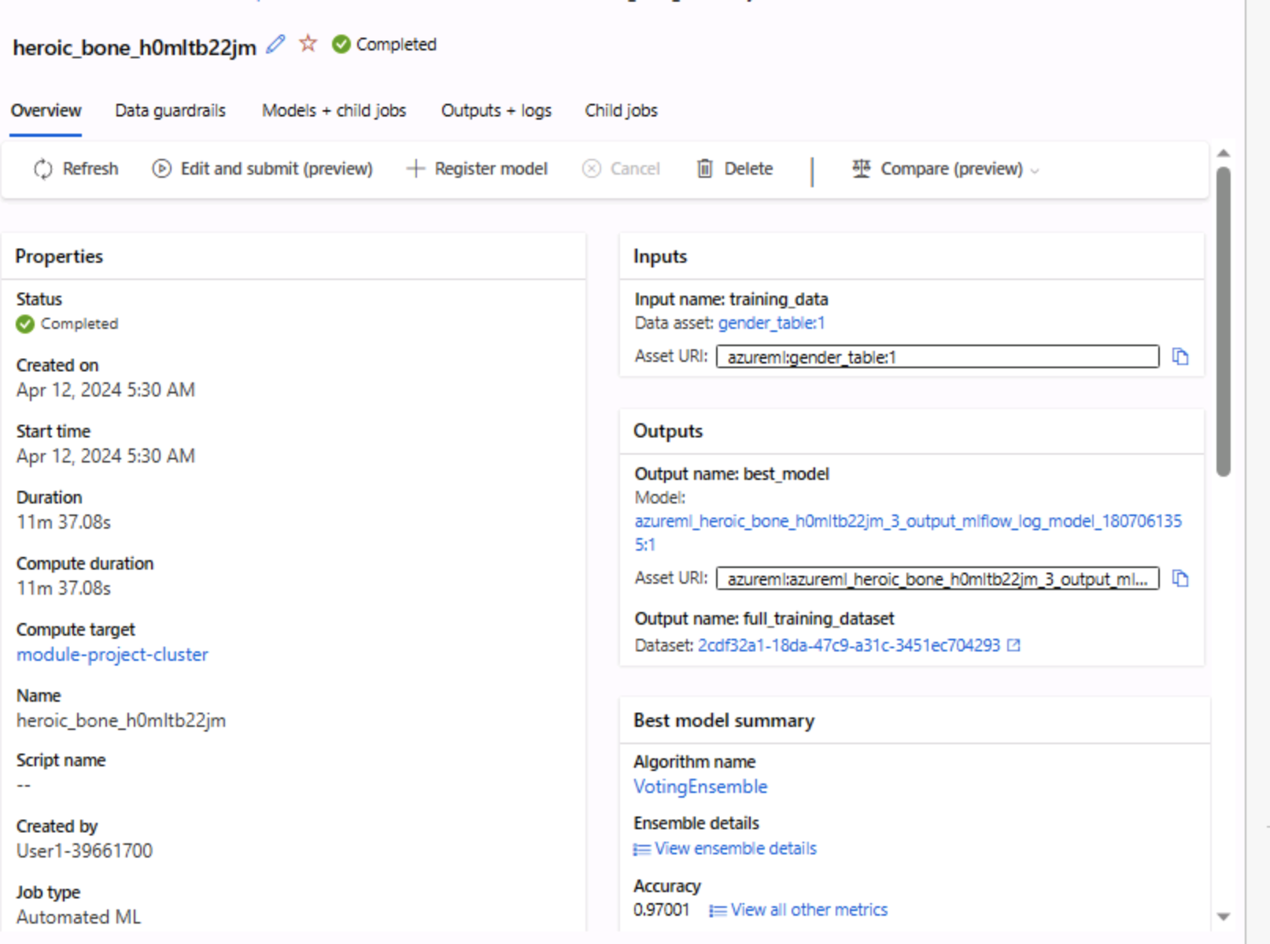

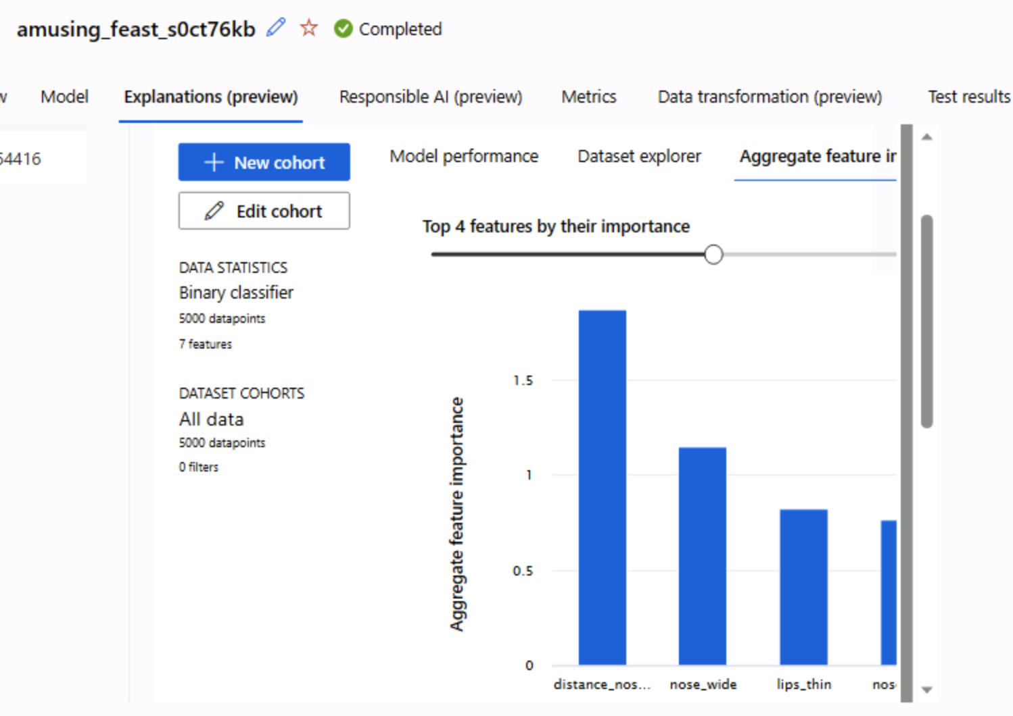

**Task 5:** Take the screenshots of automl job’s status and the logged values for each child run.

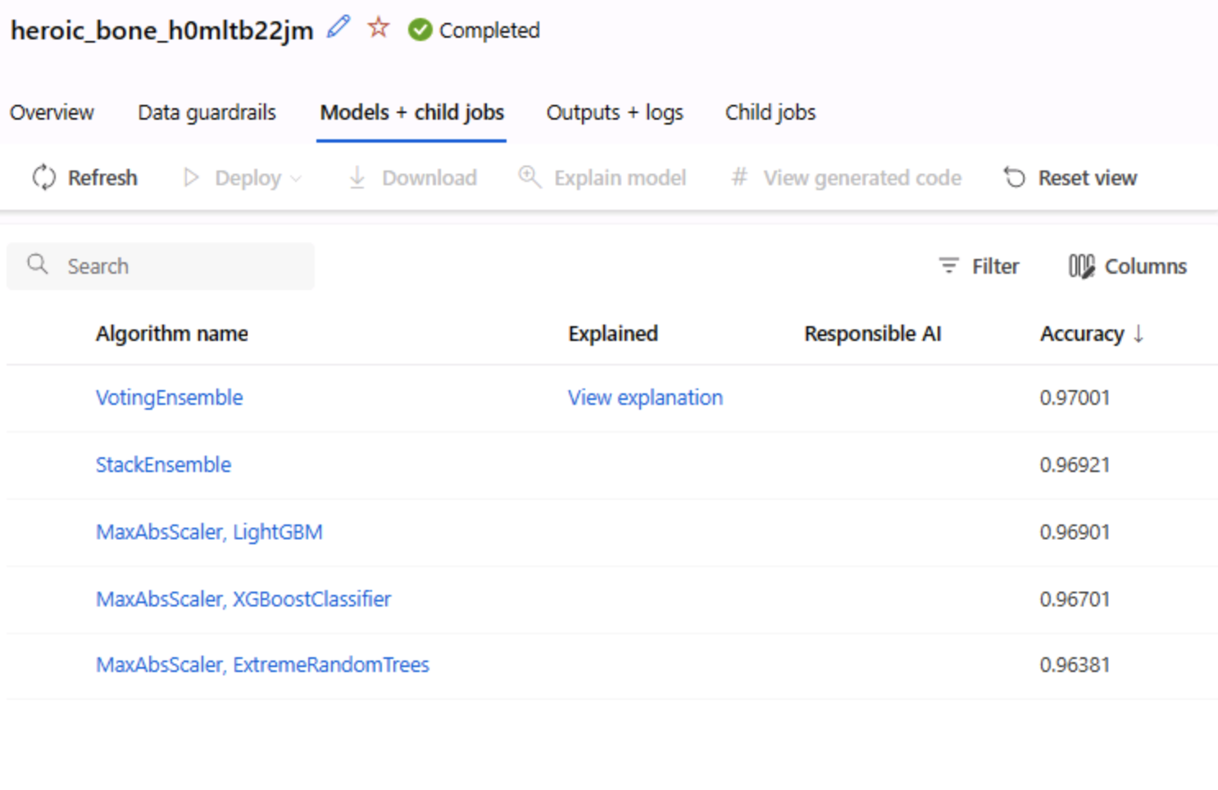

8. Conclusions and Future Directions (Include the conclusions and future directions of the project)

For this gender classification project, the AutoML job is able to train, test, and evaluate the dataset to come up with the best model—which is the VotingEnsemble model. It has a 97% accuracy so it performs well. The project is able to be completed successfully in the Azure Machine Learning environment.

From this project, it also showed that the use of Microsoft Azure Machine Learning studio is an efficient and effective way to train, test, and evaluate machine learning models for a given dataset. Particularly, its inbuild components such as the available designer pipelines minimize and reduces the coding load on users.

The current downside to the Azure Machine Learning Studio might be the 1-hour time limit given for each access in this project. Due to the strict time limit, it requires users to be very familiar with the interface to be able to complete necessary tasks in the given time limit. Otherwise, once the time limit is up, the user will have to redo the task again from scratch when logging into the lab again as the next 1-hr session.

In future for more complex projects, users may have to consider subscribing to more expensive services from Microsoft Azure to have a longer time in the system or to pay more for computes with higher processing capacity to reduce waiting time.